**Setting Up Application Environment**

**Install IBM Cloud CLI**

|  |  |
| --- | --- |
| Date | 02 NOVEMBER 2022 |
| Team ID | PNT2022TMID38972 |
| Project Name | Skill and Job Recommender Application |
| Team Members: | V. Sriram, v. Rajkumar, k. Srinivasan, R. Ramakrishnan |

**Step 1:54**

Login to your IBM Cloud [***https://cloud.ibm.com/login*** a](https://cloud.ibm.com/login)nd in-search bar you can type

**Container registery** and click to get started.

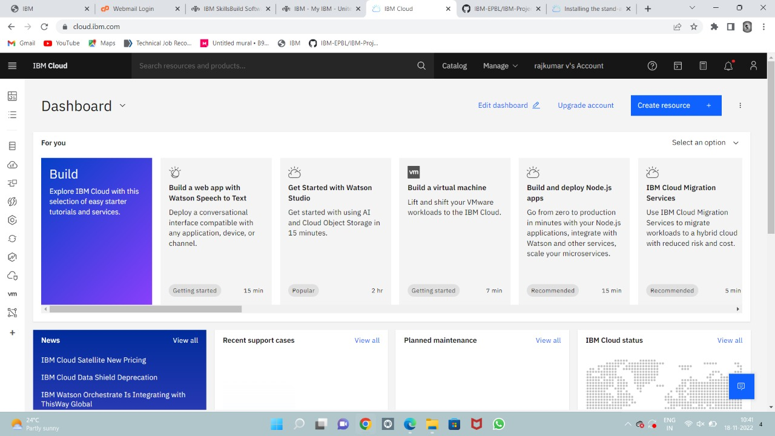

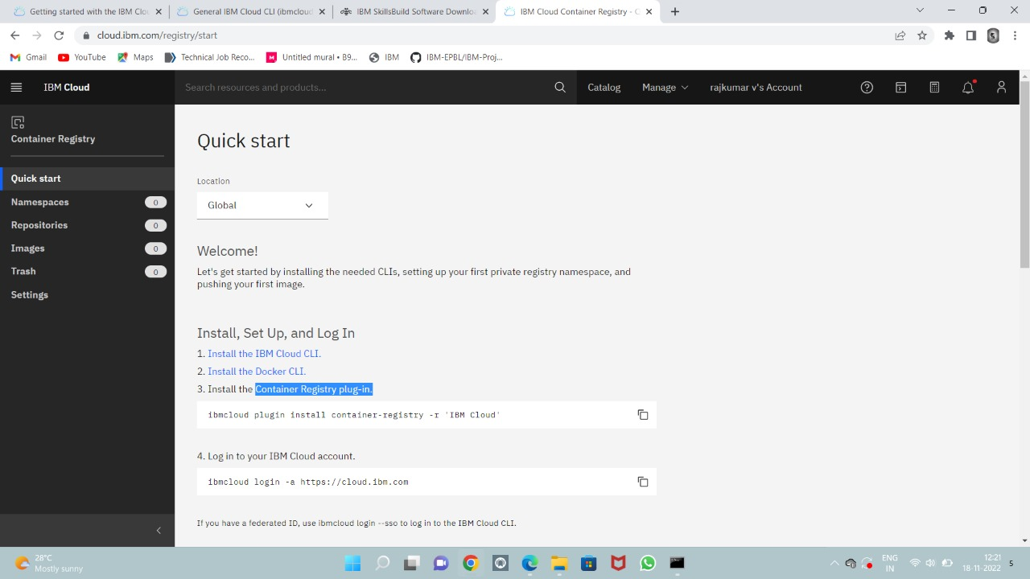

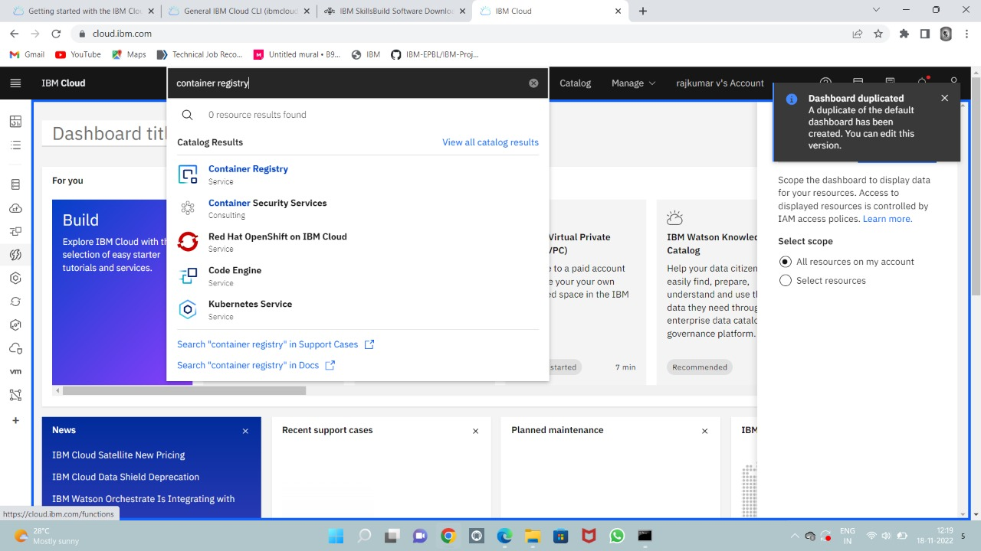

**Step 2:**

Follow and do the step given in this page one by one [***https://cloud.ibm.com/registry/ start***](https://cloud.ibm.com/registry/%20start)

**Step 3:**

Run the command in power shell,

***(New-Object Net.WebClient).DownloadString('https://clis.cloud.ibm.com***

***/install/powershell')***

**Step 4:**

Enter the command in cmd:

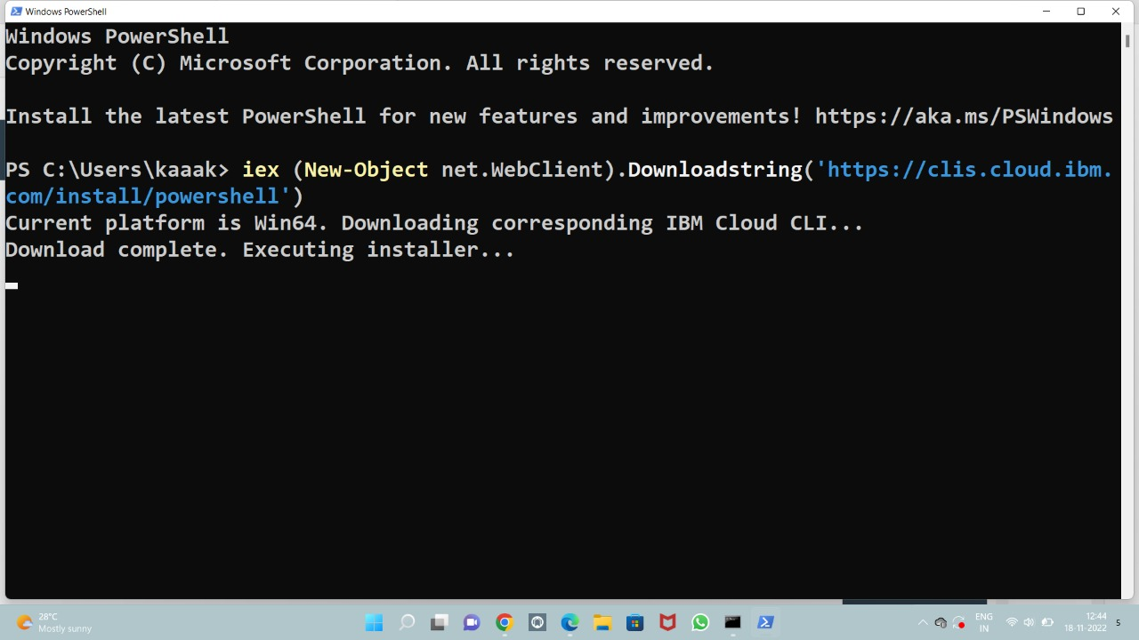

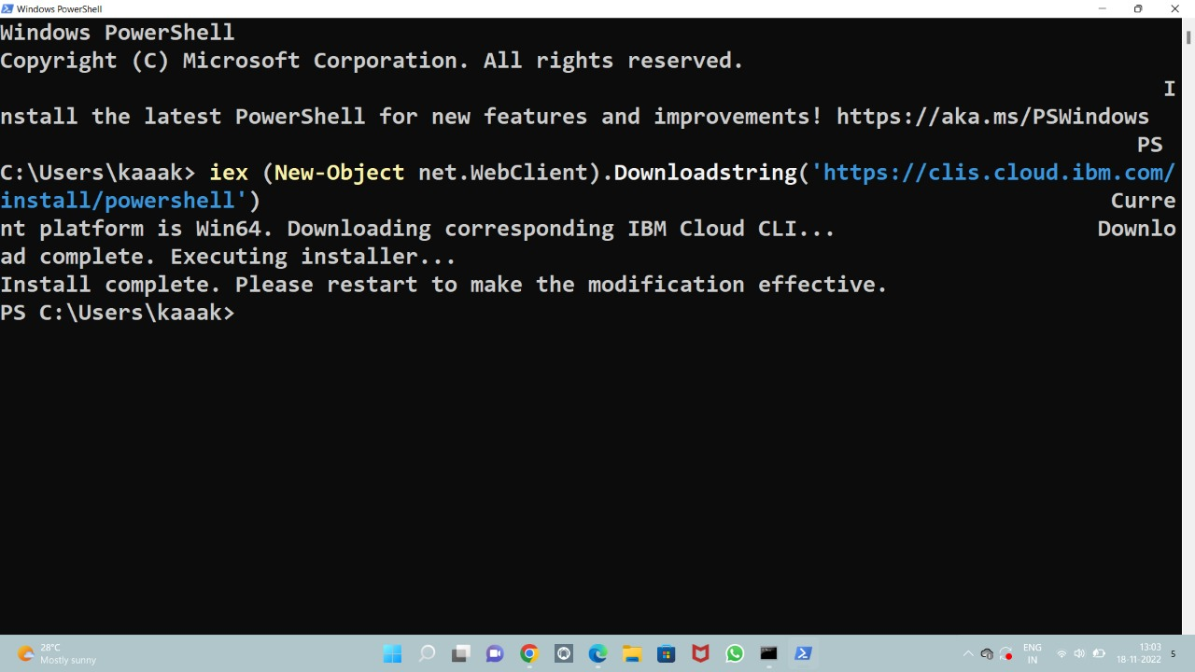

**Step 5:**

Run all the command one by one in cmd

[***https://cloud.ibm.com/docs/containers?topic=containers-cs_cli_install***](https://cloud.ibm.com/docs/containers?topic=containers-cs_cli_install)

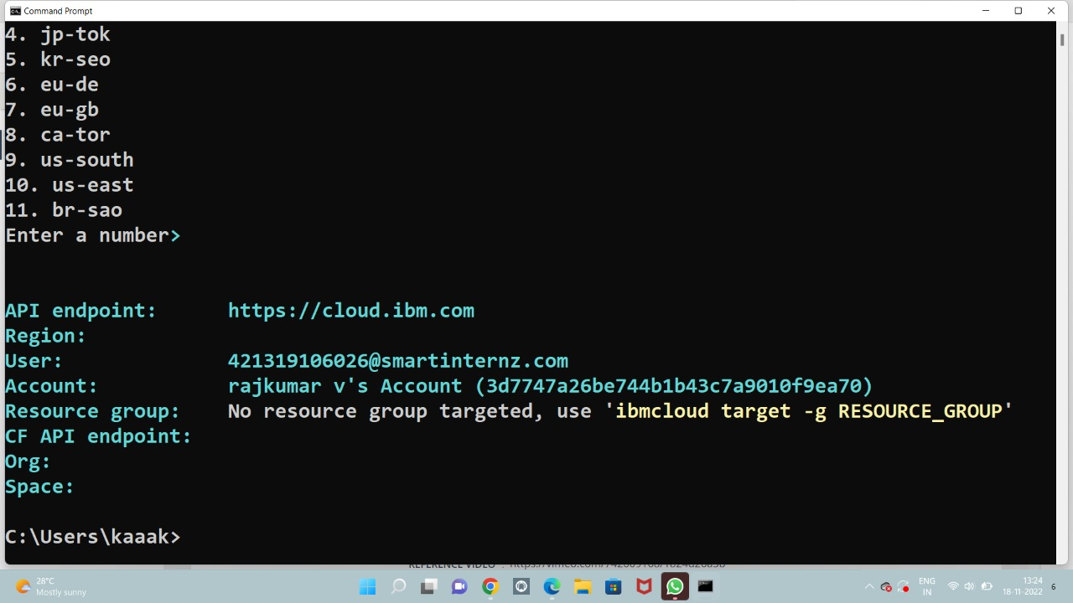

**Step 6:** Finally, you will get the IBM CLOUD CLI in your desktop